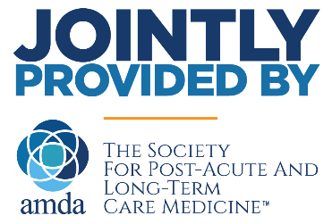
AMDA – The Society for Post-Acute and Long-Term Care Medicine
certifies that
<<Participant Name, Credentials>>
has successfully completed the <<AMA Activity Format>> titled:

<<Program Title>>
<<Dates>>, <<City, State OR Virtually>>
And is awarded:
<<# of CME>> Educational Hours/Credits*
<<# of Nursing Credits>> Nursing Contact Hours
<<# of credits>> CMD Management Hours
<<# of credits>> CMD Clinical Hours
<<# of credits>> ABIM MOC Points

Ruth Spinner, MD, CMD, Chair, Education Committee

*Credits/Hours: For physicians, this is the number of AMA PRA Category 1 Credits™ awarded.
For Physician Assistants and Nurse Practitioners, these credits have been designated as AMA PRA Category 1 Credits™ by an ACCME accredited organization and are applicable to these certifications. Please check paltc.org/continuing-education to see how you may use these credits for your profession.

CME Credit: This activity has been planned and implemented in accreditation requirements and policies of the Accreditation Council for Continuing Medical Education (ACCME) through the joint providership of AMDA - The Society for Post-Acute and Long-Term Care Medicine and (name of nonaccredited provider). AMDA - The Society for Post-Acute and Long-Term Care Medicine is accredited by the ACCME to provide continuing medical education for physicians.

CMD Credit: This live activity has been pre-approved by the American Board of Post-Acute and Long -Term Care Medicine (ABPLM) for a total of X credit hours toward certification as a Certified Medical Director (CMD) in Post- Acute and Long-Term Care medicine. The CMD program is administrated by the ABPLM. Each physician should claim only those hours of credit actually spent on the activity.

ABIM MOC Credit: Successful completion of this CME activity, which includes participation in the evaluation component, enables the participant to earn up to XX Medical Knowledge MOC points and patient safety MOC credit in the American Board of Internal Medicine’s (ABIM) Maintenance of Certification (MOC) program. It is the CME activity provider’s responsibility to submit participant completion information to ACCME for the purpose of granting ABIM MOC credit.

